Applicability: (Specify instrument, location and/or project to which this RSP applies)
Focused Ion Beam (FIB) in the Microscopy and Characterization Suite.
Radiological Work Scope: (Describe how rad materials and sources will be used in the project/activity)
Analysis of rad samples in the FIB; confirmation of no contamination at completion of analysis.
- Insure the sample rad readings are taken and compared to expected levels.
- Prep all work areas.
  - Cover work area(s) with towels.
  - Position tools needed for sample/stub prep.
  - Place sample on FIB compatible carrier (stub or directly mounted to 4” multi position sample holder) and place sample on a carrying tray to move to the FIB (place towels in the base of the tray under the sample to catch any loose contamination). See photo#1 for an example of work area setup.
NOTE: Change outer pair of gloves anytime you touch the sample.
- Use sample tray to transport sample to FIB room.

Photo #1: This photo shows an example of how you want to set up your work area for the samples to be prepped for the FIB and the sample cart.
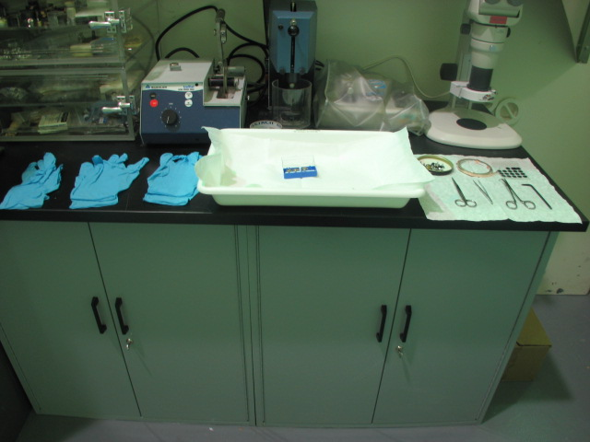

- At the FIB Microscope Base, preposition pairs of gloves for glove exchange during FIB loading and towels as shown below on the microscope base and console. Preposition tools and other supplies that you will need during the loading of the sample in the FIB (wrenches, screw driver, Cu tape, etc.) See photos #2, #3.

Photo #2: Cart with the tray, gloves and sample on it.
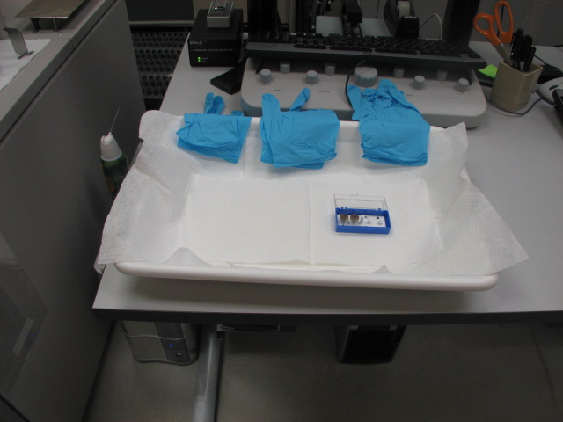

- Place configured sample/tray combination next to the FIB base as seen in photo #3. Note the towel, supplies and tool placement.

Photo#3: Sample tray next to the microscope base.
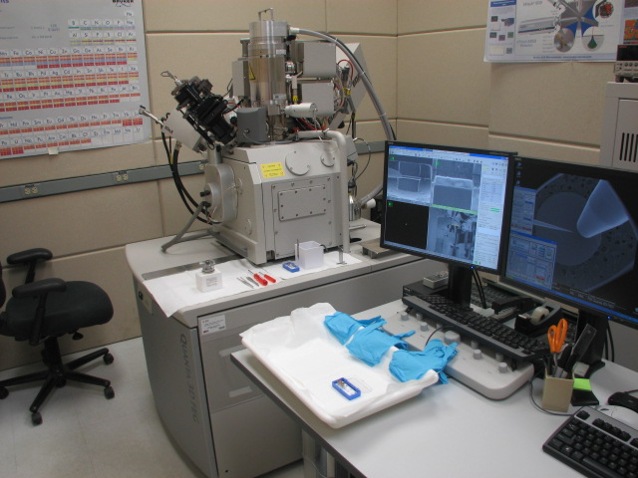

- Vent microscope and load sample. At anytime your gloved hands touch the sample/holder and then released to reach for equipment (tweezers, tools, etc) away from the toweled area, change your outer pair of gloves to minimize cross contamination possibilities. A good work practice for contamination control is to have an assistant hand you gloves and tools instead of reaching. Once the chamber door is closed and chamber is under vacuum, place a Rad Sticker with the recorded readings, on the chamber door. This indicates that a Rad sample is loaded in the FIB (as a visible warning).
Once work is complete on the FIB. To unload, Rad surveys need to be taken as you proceed to remove the samples from the FIB.
- Start by collecting your Rad instrument cart and positioning it near the FIB so that it is easily accessible. Set up the FIB and cart as shown in step #5.
- Vent the chamber. Insure that the chamber door stays closed.
- Once the chamber is vented. Open the chamber door. Take smears of the stage and sample carrier. Close the chamber door. Take “smears” to counter. See photos #4 and#5
- Contamination (dpm/100 cm² beta/gamma): < 70 dpm/100cm²; if greater than 70 dpm/100cm² stop work, contact the CSO and/or laboratory lead, decontaminate, and survey
- Contamination (dpm/ 100 cm² alpha): < 7 dpm/100cm²; if greater than 7 dpm/100cm² stop work leaving equipment n a safe status, contact the CSO and/or laboratory lead decontaminate, and re-survey

Photo #4 Photo #5
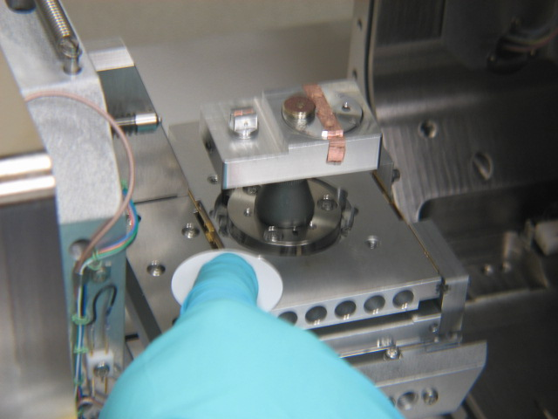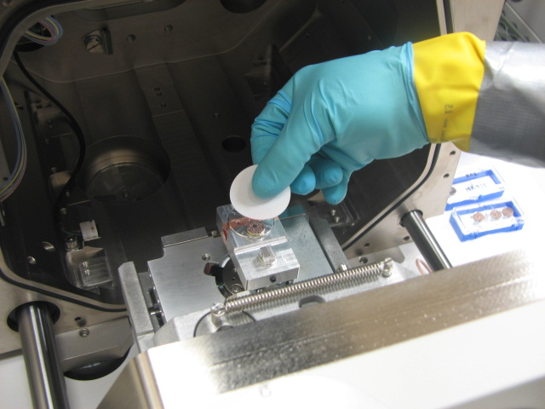
Once smears are determined to be “clean”, proceed to remove the sample from the FIB in reverse order from step 5 to step 1.
All gloves, towels and other waste needs to be collected, placed on the carrying tray to carry to the Rad Waste Bin. Place in used material in the Rad waste can.
Operating Envelope: (Describe the permissible rad parameters for this activity)
Estimated Dose (person-mrem) anticipated for work activity: <100 mrem
Radiological Conditions: (List the allowable work conditions such as those listed below and when not applicable specify as NA)
- General area (mRad/hr) beta/gamma: < 70mR/hr at 30cm
- General area (mrem/hr) neutron: NA
- Contact (mRad/hr) beta/gamma: Variable as a function of the source used.
- Contamination (dpm/100 cm² beta/gamma): < 70 dpm/100cm²; if greater than 70 dpm/100cm² stop work, contact the CSO and/or laboratory lead, decontaminate, and survey
- Contamination (dpm/ 100 cm² alpha): < 7 dpm/100cm²; if greater than 7 dpm/100cm² stop work leaving equipment n a safe status, contact the CSO and/or laboratory lead, decontaminate, and re-survey
- Airborne activity (µCi/mL): This project is not anticipated to generate any airborne radioactive contamination; however, TSO staff will obtain confirmatory air samples.
- Derived airborne concentration (DAC): N/A
- Other: None
Contamination Protocol: (Describe who, when, what and how contamination is prevented and surveyed)
See work scope above.
Dosimetry Requirements:
Dosimetry Type: | Whole body beta/gamma dosimeter |  |  |  |  | Whole body neutron dosimeter
 | Multi-pack type:
 | Electronic dosimeter (ED) |  |  | Extremity dosimetry (optional at discretion of performer
Lab Lead/CAES Safety Officer Coverage: |  |  | Continuous |  | End of work |  | At job start | Periodic
PPE requirements (List the required PPE when performing rad work): Lab Coat, glove liners, heavy gloves taped to lab coat with “Duct Tape”, nitrile outer gloves and safety glasses.

Required Training:

- Standard CAES Rad Training: ISU Radiation Introduction Training
MaCS General Rad Practice (RSP-002)
General Radiation Safety Training
Rad Primer and Lab Orientation
Area and Contamination Surveys
Generic Instrument (RSP-001)

Activity/Project-Specific Radiation Safety Training: (List training and who it applies to by research/job function). None

Special Conditions:

Contamination Control (Specify protocols such as how to transport samples, glove changing, etc.): See work scope above.

Survey Requirements: (Specify appropriate protocols, e.g., survey requirements for entering and leaving posted areas, conducting contamination surveys, and equipment surveys) .
See work scope above

Evaluation Points: (Specify predetermined points in time or process when and what evaluation is to be made, e.g., instruments must be surveyed for contamination before and after the analysis of each sample.
Limiting Conditions That Void the RSP: (Specify conditions that void the RSP such as smearable contamination above a limit, radiation levels above a limit, personnel frisk identifies contamination when exiting the work area.)
If any of these conditions are met, Stop Work, place job in safe condition, cease use of this RSP as written and notify the Lab Lead and CSO.
Best Practices:
Follow good ALARA Practices when handling radiological sources:
Minimize time in which radioactive sources are exposed.
Perform frequent surveys of work areas.

